Create a new branch ‘js-assignments’.

2. Switch to ‘js-assignments’ branch.

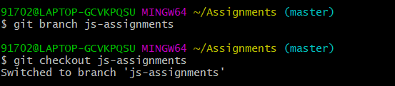

3. Copy all JavaScript assignments inside ‘Assignments’ folder.

4. Commit JavaScript assignments into ‘js-assignments’ branch.

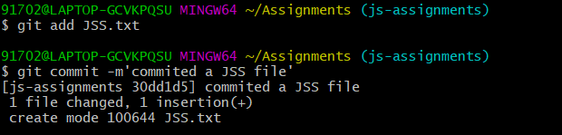

5. Make minor changes into README.txt file on line 1 belonging to ‘js-assignments’ branch.

6. Commit those changed files.

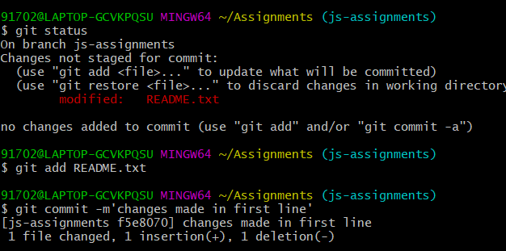

7. Switch to master branch.

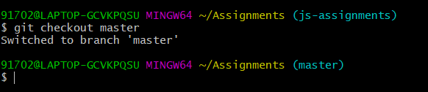

8. Make minor changes into README.txt file on line 1 & commit those changes into

master.

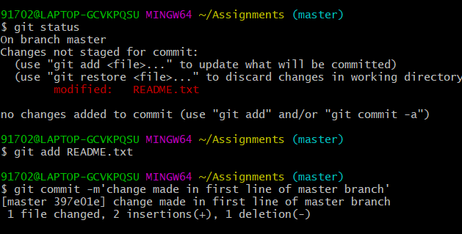9. Again switch to ‘js-assignments’ branch.

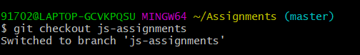

10. Make minor changes into few files belonging to ‘js-assignments’ branch.

11. Commit those changes.

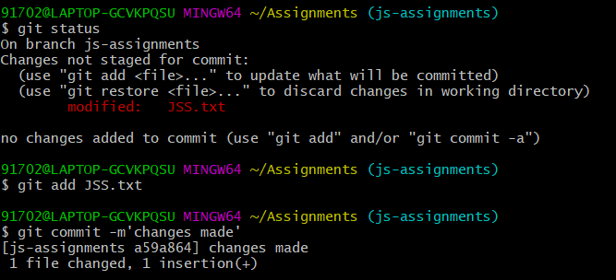

12. Switch to master.

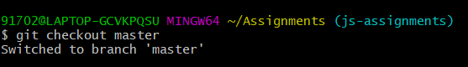

13. Merge ‘js-assignments’ branch into master. Confirm all JavaScript assignments are

shown in master.

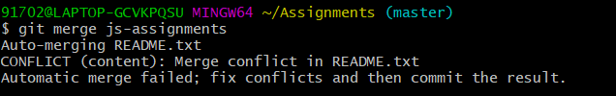

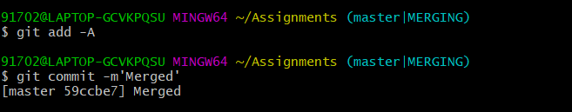

14. Finally delete the ‘js-assignments’ branch

